1. Calculate the areal mean total precipitation in Volta Basin.
   1. Prepare GPM (raster) and Volta outline (vector) data, then drop them into QGIS panel.
   2. Clip GPM data by boundary near Volta basin as to reduce unnecessary storage.

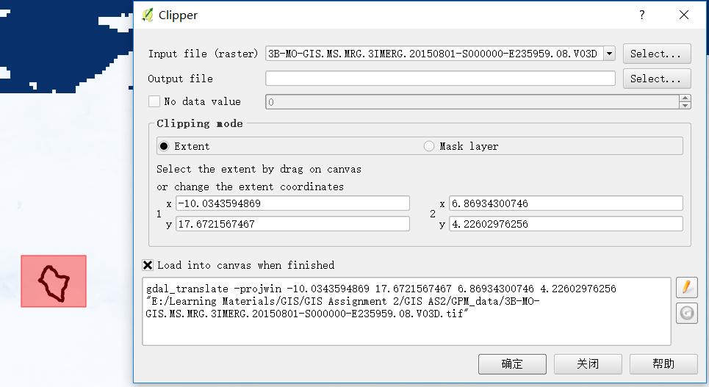

* 1. In order to evaluate areal average monthly precipitation inside Volta basin area, firstly convert units from 0.001 mm/hour to mm/month using raster calculator and then zonal statistics is utilized by taking sum into account.

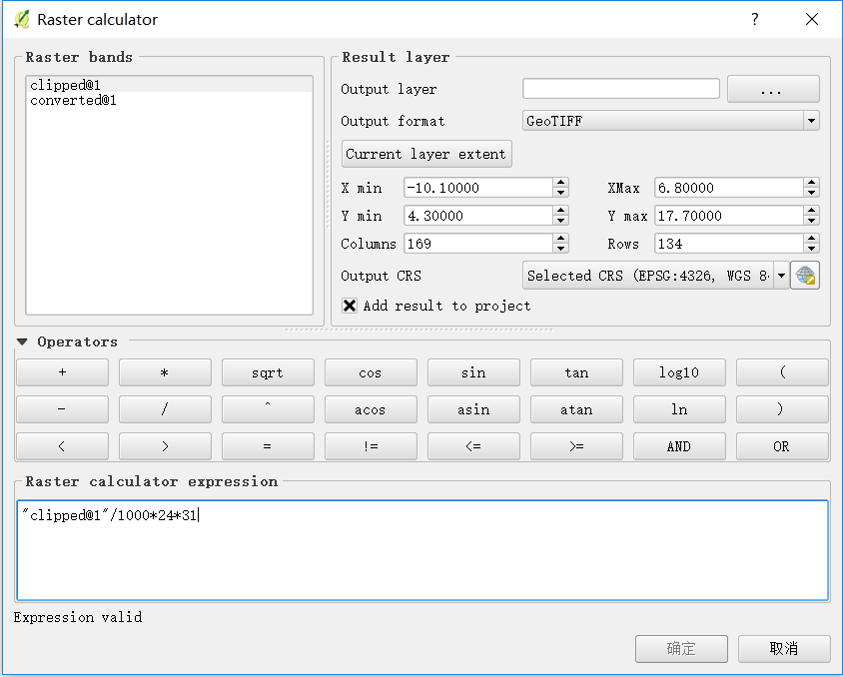

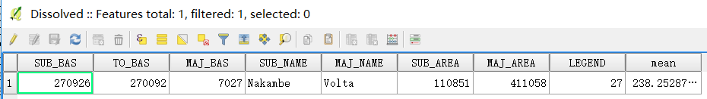

1. Install gauges and estimate mean areal rainfall by interpolation
   1. Estimate average monthly rainfall
      1. Randomly install 10 gauges inside Volta basin domain by “Random Points Inside Polygons”

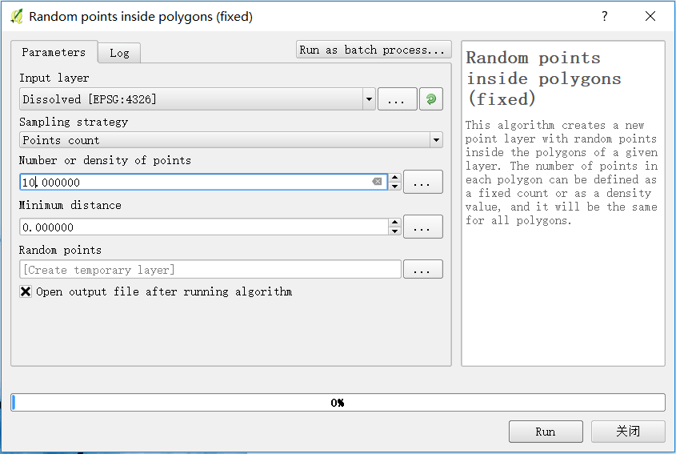

* + 1. Install “Point Sampling Tools” and get values from GPM

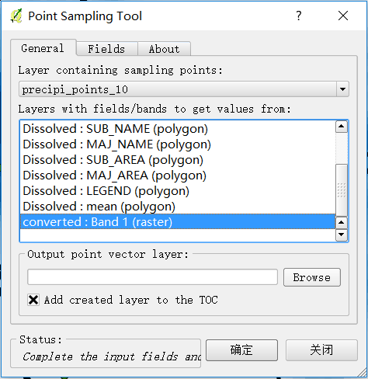

* + 1. Interpolate precipitation data with known 10 random gauges by ”Interpolation Plugin”.

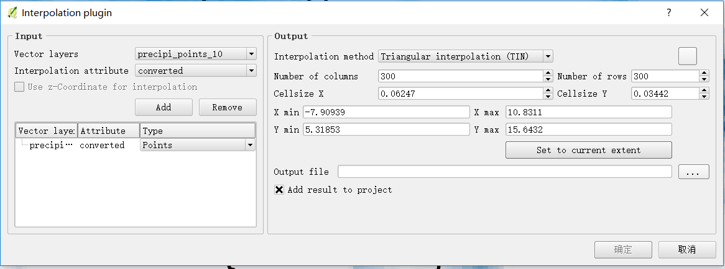

* + 1. Again, estimate monthly average areal rainfall by zonal statistics. The result of this approaching is 211.81mm/month.
    2. Iteratively adding 20 and 50 gauges and interpolate as before, see results inside one attribute table as shown below.

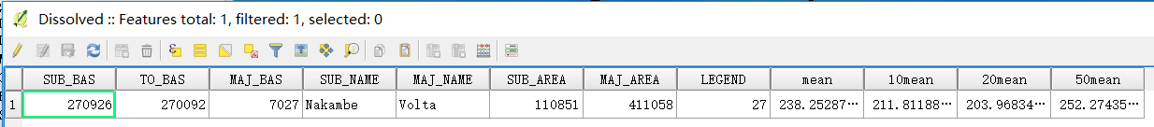

* 1. Maps of precipitation in Volta basin.

|  |  |
| --- | --- |
|  |  |
|  |  |

|  |  |  |  |  |
| --- | --- | --- | --- | --- |
| Points | Original | 10 | 20 | 50 |
| Precipitation(mm/month) | 238.25 | 211.81 | 203.97 | 252.27 |
| Difference(absolute) | 0 | 26.44 | 34.27 | 14.02 |

* 1. In my process, the gap between approach and original one goes up from 10 points to 20 points and then fall at 50 points. The performance of 10 points is even better than 20 points in this case as the initial 10 points represent more distinct features than 20 points from the map comparison.
  2. The differences of values are caused by randomly introduced points. These points stand for the features of the model. Because of interpolation process, the intermediate values are evaluated based on neighboring points and defined weights.
  3. As we see, generally, more gauges installed on the map, narrower the gap between actual monthly mean areal value to approaches. This is obviously due to the representative features of large points. To an extreme extent, the modeled value could be the same as original one if the amount of points is infinitely large.
  4. Clearly, standard deviation is reducing from 10 points to 50 points because more samples represent more distinct values in GPM. In original one, there should be no standard deviation as everyone is on the right track and everyone’s solution approaches to the same as points increase.